Silent Install and Enrollment of Mac Workstations into MAX Remote Management

This document will walk through using Apple Remote Desktop to silent deploy and enroll your Macs into the MAX Remote Management environment. We encourage the use of our Active Discovery feature, but this may be more appropriate in certain environments.

Create Client and Site

Create the Client and Site that you wish to use inside the Remote Management Dashboard. (Note: in future versions of the script, creation of client/site will be done automatically.)

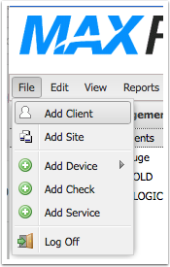

Download the OS X Agent (optional)

If you choose not to download the OS X Agent, the script can do it for you. But doing it yourself may conserve bandwidth and speed up the process.

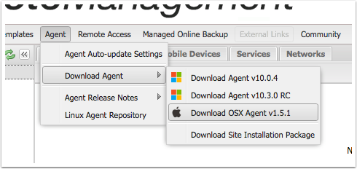

Deploy the OS X Agent .pkg (optional)

If you chose to download the .pkg, deploy it using your existing deployment tool. In this document, we will use Apple Remote Desktop. Mount the downloaded .dmg file and open it. The .pkg is inside.

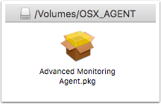

In Apple Remote Desktop, select the computers you wish to enroll and then choose "Install Packages..." from the "Manage" menu. Drag the "Advance Monitoring Agent.pkg" from the mounted disk image into the window (or click "+" to find it). Set the options as shown below and then click "Install."

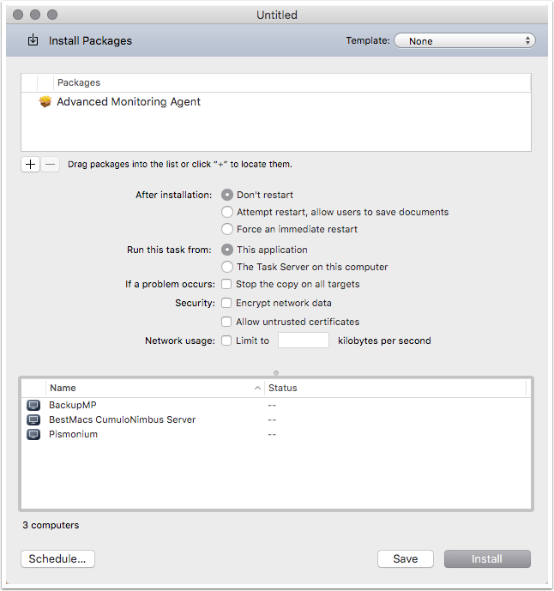

Deploy the macSilentInstall script

Download the macSilentInstall.sh script from

<https://github.com/logicnow/macSilentInstall>

In Apple Remote Desktop, select the computers you wish to enroll and then choose "Copy Items..." from the "Manage" menu. Drag the "macSilentInstall.sh" file from your downloads into the window (or click "+" to find it).

Under "Place items in:" (highlighted below) choose "Specify full path..."

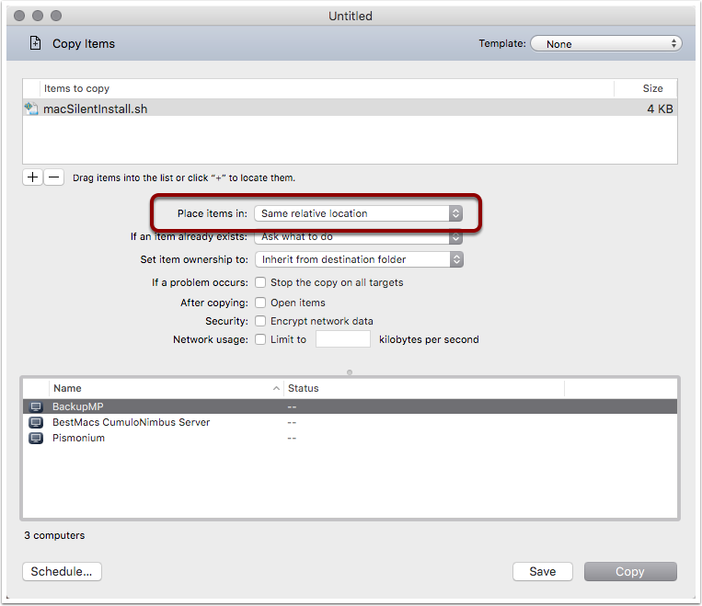

Enter

/private/tmp

and click "OK." Leave the rest of the options at default values and then click "Copy"

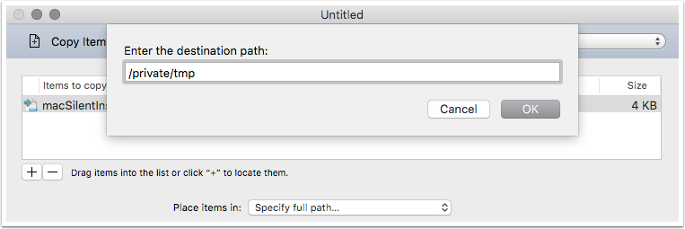

Send UNIX Command to execute script

Select the computers you want to enroll and then click the button for "Send UNIX Command" or choose it from the "Manage" menu.

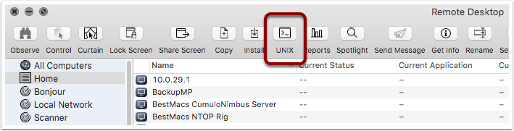

If you chose to download and install the .pkg using the steps above, enter this command:

bash /private/tmp/macSilentInstall.sh username password client site --registeronly

Otherwise, leave off the "--registeronly" so the command is:

bash /private/tmp/macSilentInstall.sh username password client site

Change the variables to match your actual desired config. Here's some sample data:

bash /private/tmp/macSilentInstall.sh 'me@pretendco.com' 'password123!' 'My Awesome Client' 'KC Office'

Note that the variables are in single quotes to protect white space and special characters.

Change the User field so it says "root" (see highlighted below) and then click "Send"

